Microservice and Web Engineering

Prof. Thiago Souza Xavier

Global Solutions – 3SIR

Enzo Massayuki Obayashi **RM:95634**

João Pedro Moura Tuneli **RM:93530**

**https://github.com/joaotuneli56/energia-monitor.git**

**São Paulo 2024**

**Evidências de Funcionamento**

**Evidências de erro (404,401)**

* **GET**

[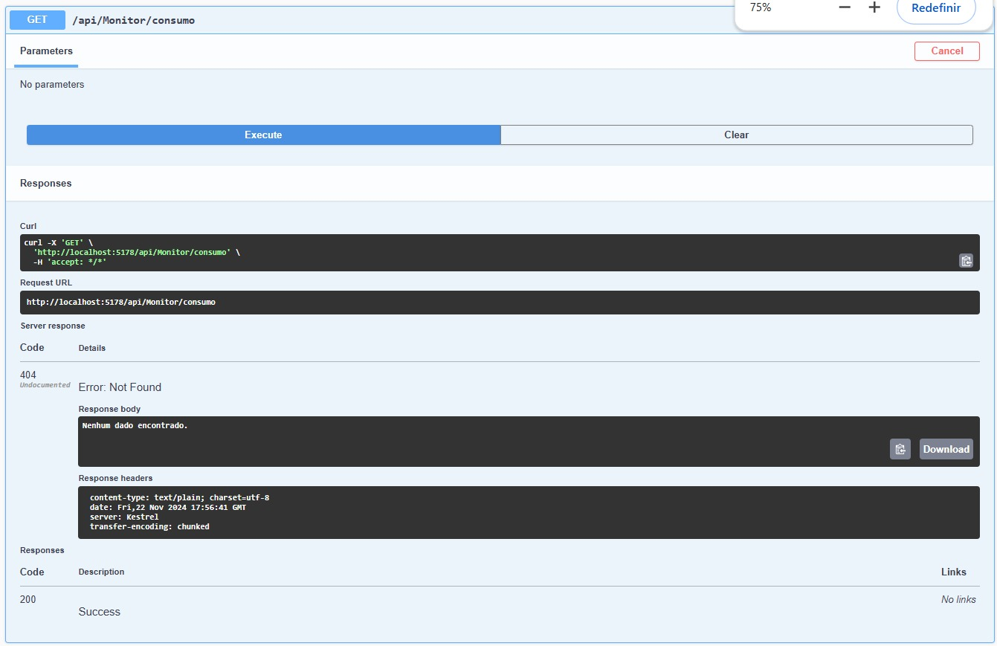](https://github.com/joaotuneli56/energia-monitor/blob/master/evidencias/status404get.jpeg)

* **POST**

[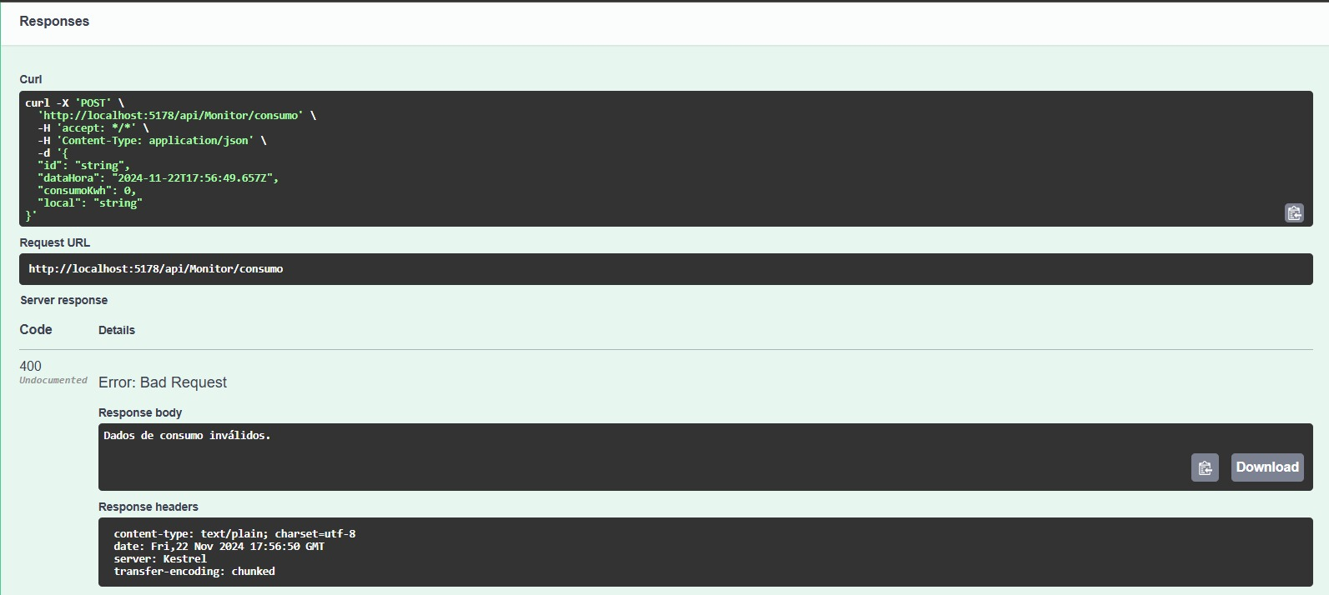](https://github.com/joaotuneli56/energia-monitor/blob/master/evidencias/status400post.jpeg)

**Requisições funcionando**

* **GET**

[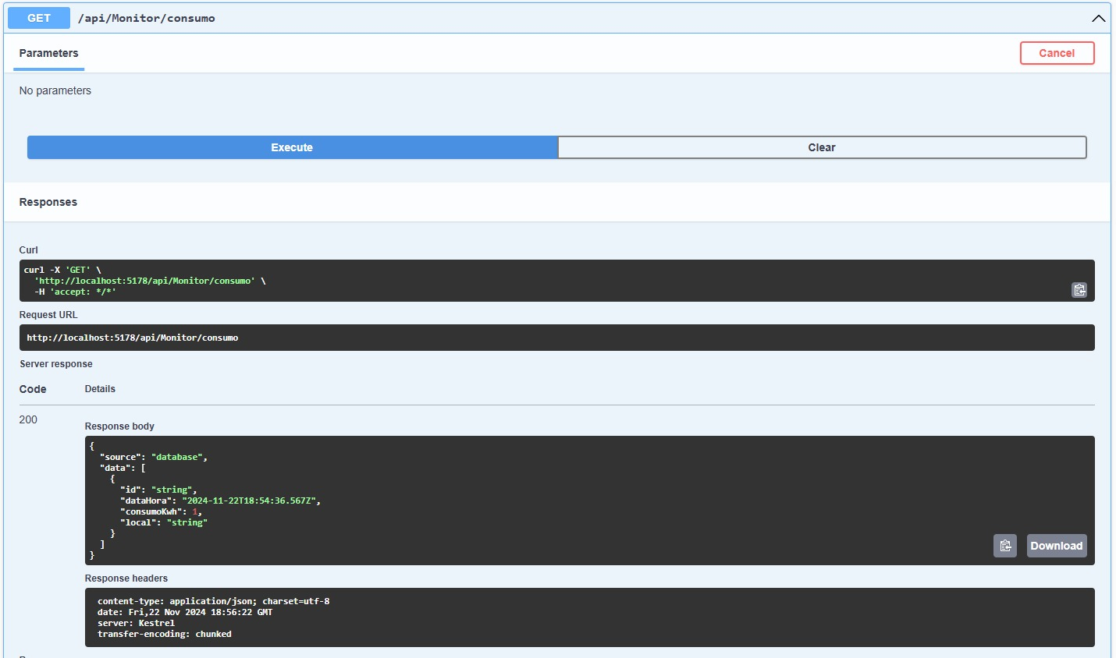](https://github.com/joaotuneli56/energia-monitor/blob/master/evidencias/status200get.jpeg)

* **POST**

[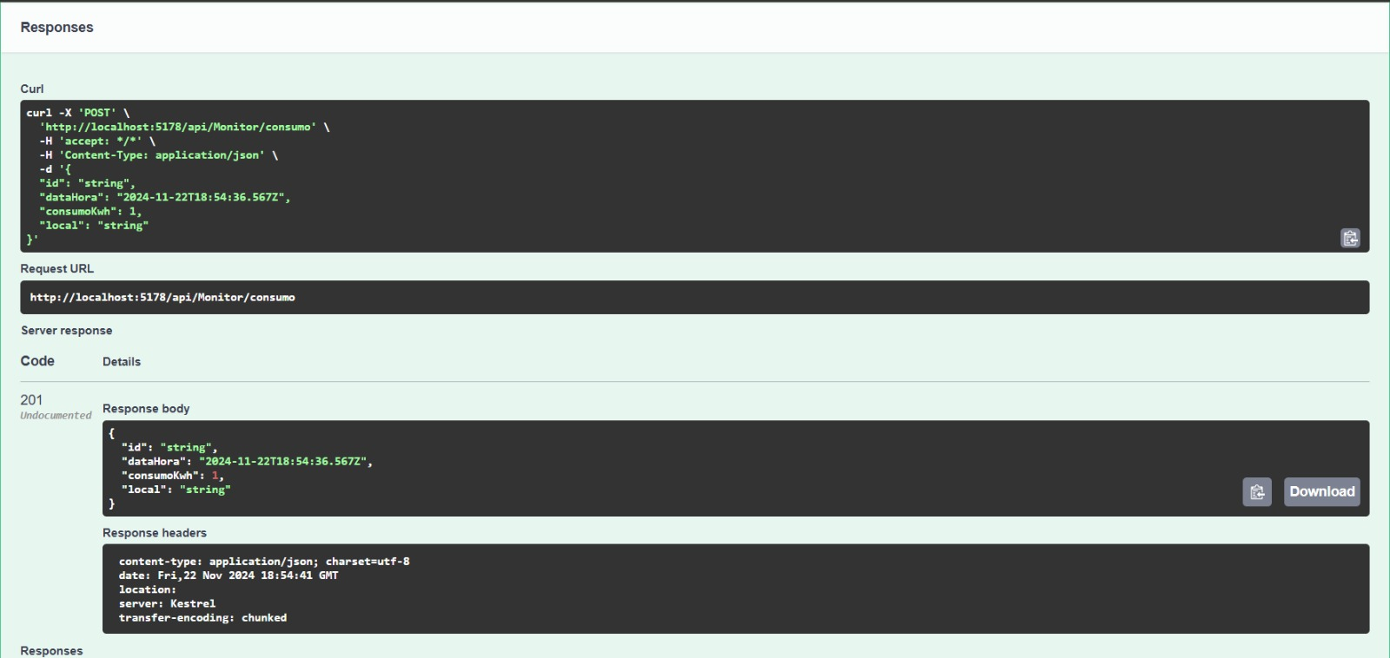](https://github.com/joaotuneli56/energia-monitor/blob/master/evidencias/status201post.jpeg)

* **Serviço Operacional(Health)**

[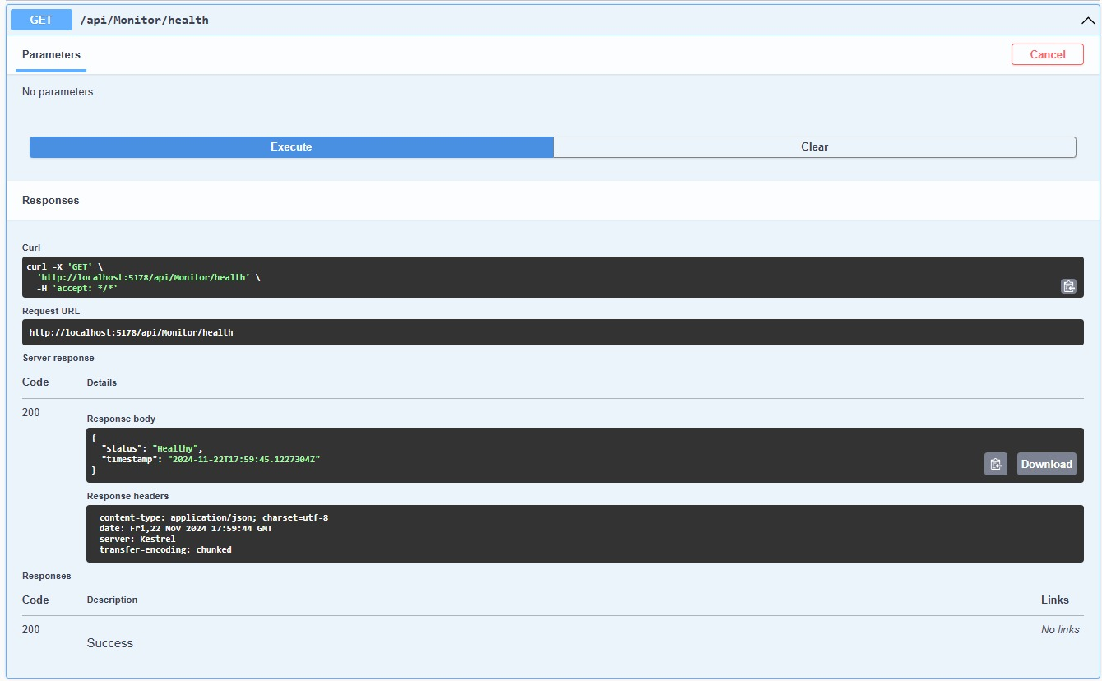](https://github.com/joaotuneli56/energia-monitor/blob/master/evidencias/servi%C3%A7oemfuncionamento.jpeg)